1a.
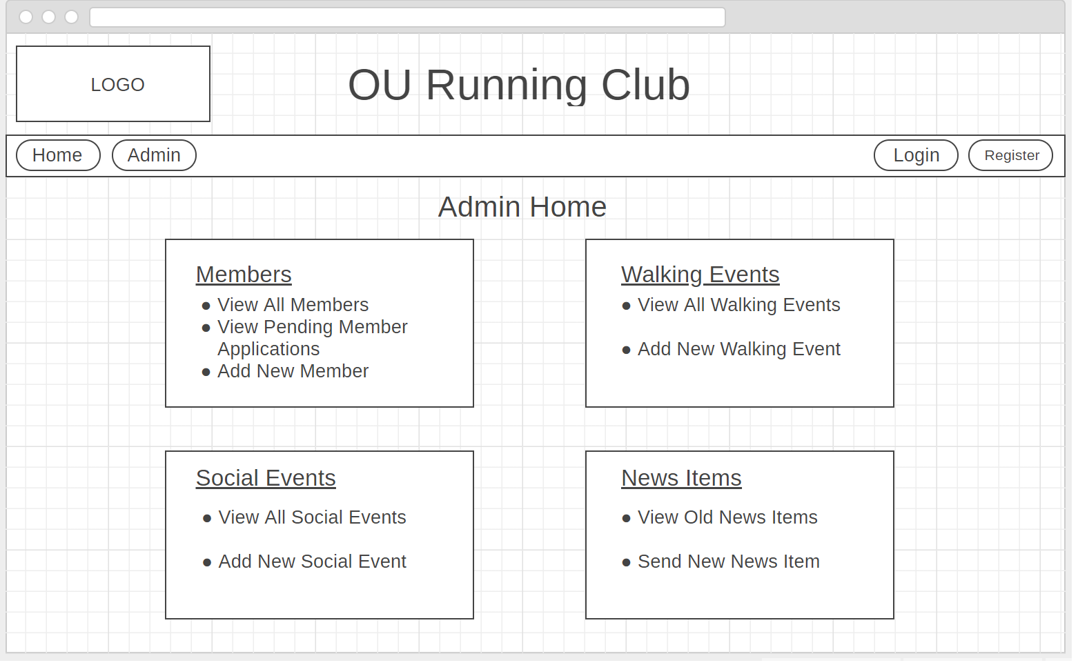 | This is the home page for the admin section of the OURC website in desktop mode. From here users can access pages to view/add/edit members, walking events, social events, and news items.
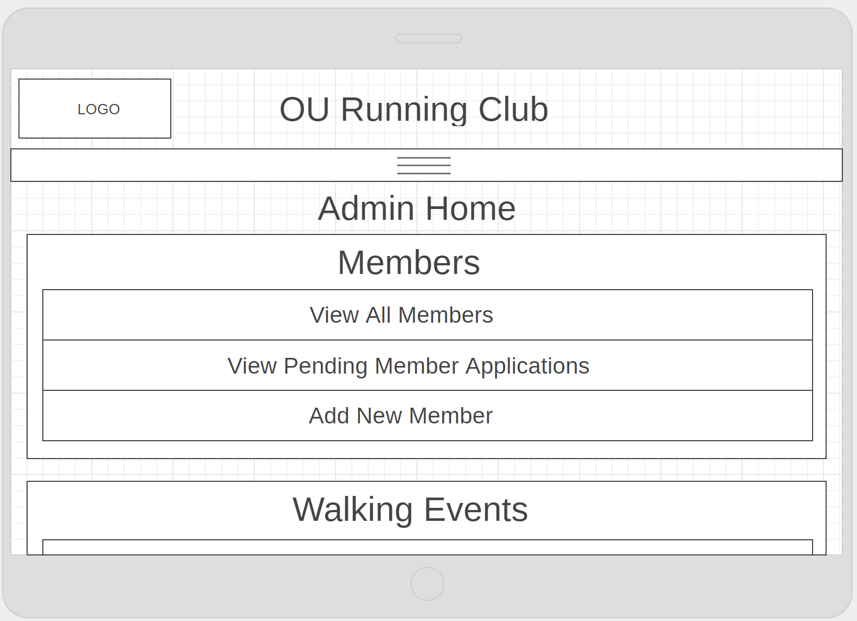 | This is the mobile version of the OURC admin home page. Instead of the sections being in a 2x2 grid they are now larger and listed for ease of use on a mobile device.
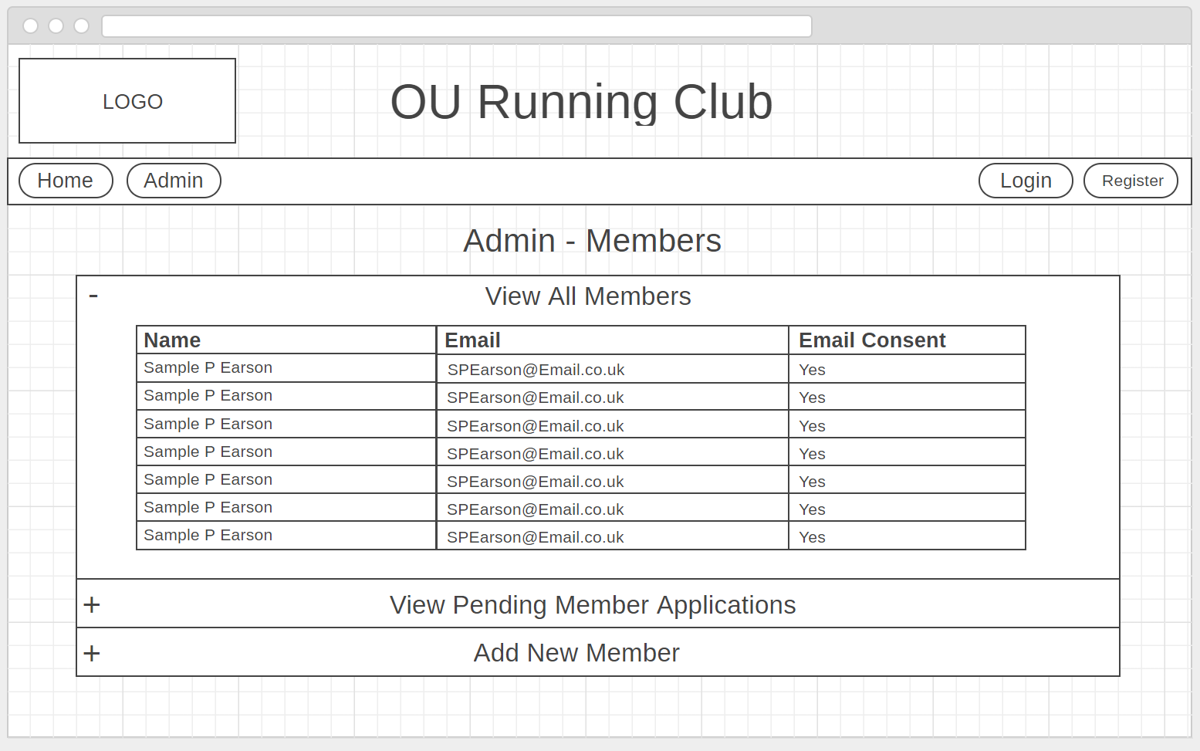 | This is the Members section of the admin area. Each section can be shown or hidden using the “+” and “-” points. The page will open with the relevant section shown depending on the link selected from the admin home page.
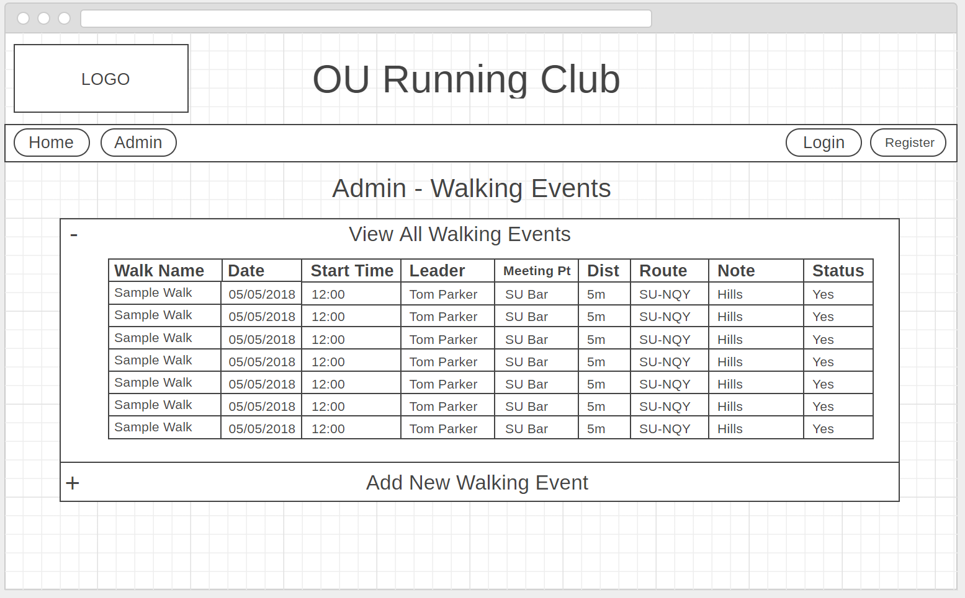 | This is the Walking Events section of the admin area. Each section can be shown or hidden using the “+” and “-” points. The page will open with the relevant section shown depending on the link selected from the admin home page.
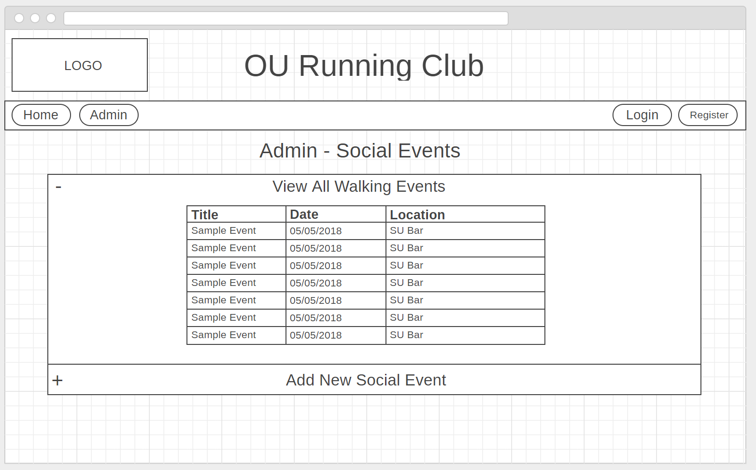 | This is the Social Events section of the admin area. Each section can be shown or hidden using the “+” and “-” points. The page will open with the relevant section shown depending on the link selected from the admin home page.
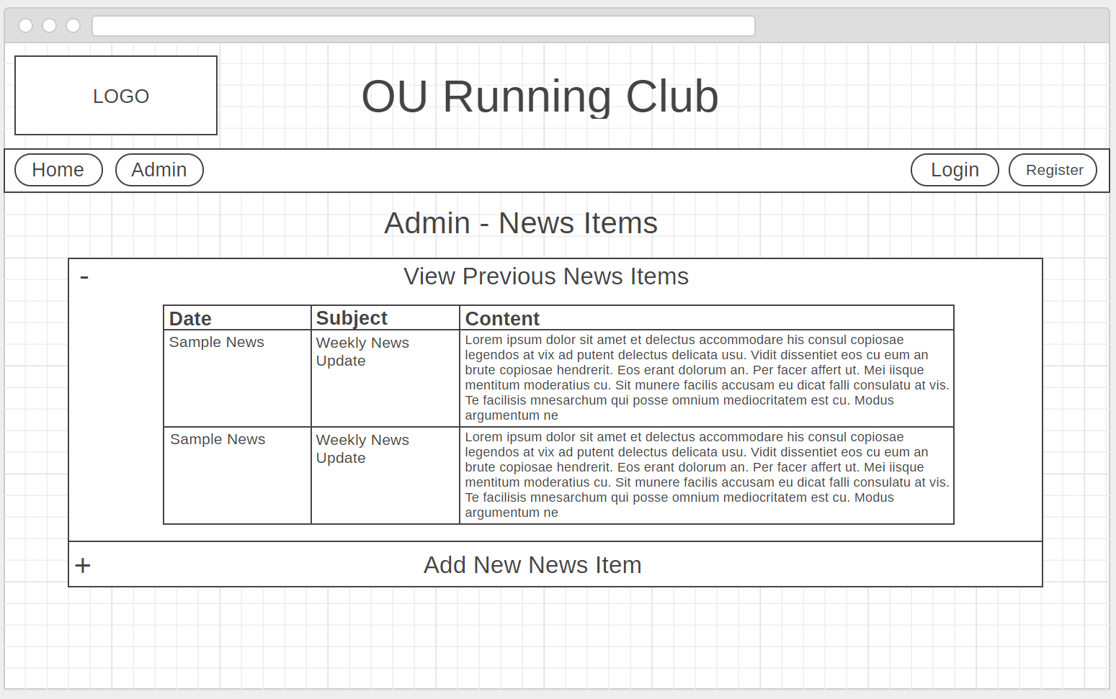 | This is the News Items section of the admin area. Each section can be shown or hidden using the “+” and “-” points. The page will open with the relevant section shown depending on the link selected from the admin home page.

1b.

I have created a series of wireframe images to illustrate how the administration section of the OURC website will be laid out and navigated. I have also included a mobile version of the admin home page to show how it will adapt to handheld devices.

I will create a template for the website that will keep the structure and look similar throughout the website. This template includes a header with a logo and title, and a navigation bar with links to the home page and admin page as well as links to the login and registration pages. The main section of the home page will be set out in to a 2-column grid with each different subject (members, events, news) in its own section, this will make it easier to adapt to mobile devices by changing to a single column layout (plus other tweaks).

The mobile layout of the home page will have the same logo and title as the desktop version, for ease of use, the link bar below the title will change to a hamburger style dropdown menu. As mentioned in the paragraph above, the content will be ordered in to a single column of boxes that contain subjects and their sub-links.

The main admin page will primarily link to 4 pages and their subsections, members, walking events, social events, and news. These pages will be organised in to subsections with each of these subsections individually viewed by clicking its + or – buttons that will show/hide it.

The member page will have three sections, the first section of the member page will display the name, email, and email consent of all current members of the OURC. The second section of the member page will allow the user to view/accept/reject all pending member applications.

The walking events and social events pages will each contain two sections, the first will allow the user to view all their respective events and the second will allow the user to add a new event.

The news item page will contain two sections, the first will allow the user to view all previously sent news items and the second will allow the user to create and send a new news item.

2.

